
Date : 21st Oct 2019

Name: Mr. MAHESH KUMAR PARVATHAREDDY
E-mail id: mahesh@sdlglobe.com
Phone no: +91- 8095551055

HRMS – Design & Functional Requirement Document

Our Location:
SmartDrive Labs Technologies India Pvt. Ltd.
# 83, 4th Main, 8th Cross, AG’s layout
New BEL Road, Bangalore – 560 054
Karnataka, India.
CONFIDENTIALITY STATEMENT
This document contains proprietary trade secret and confidential information to be used solely for evaluating SDL. Customer, by accepting this document, agrees that neither this document nor the information disclosed herein, nor any part thereof, shall be reproduced or transferred to other documents, or used or disclosed to others for any purpose except as specifically authorized in writing by SDL.

Copyright © SMARTDRIVE LABS TECHNOLOGIES INDIA PVT LTD. All rights reserved. All product and company names mentioned herein are trademarks or registered trademarks of their respective companies.

ATTENDANCE MODULE
- Create Shift Master
- View / Edit Shift Master
- Create Attendance Rule
- View / Edit Attendance Rule
- Create Holiday
- View / Edit Holiday Master
- Shift Mapping
- Process Attendance
- Overwrite Attendance
- Upload EmpCode IP and Machine Code Mapping
- Report EmpCode IP and Machine Code Mapping
- Create EmpCode IP and Machine Code Mapping
- Attendance Manual Entry
- Comp Off Apply & Updated by HR
- OD Apply and Update by HR
- Apply OD/WFH
- OD/WFH Status

Shift Master:
This includes the following menus:
- Create Shift master
- View/ Edit Shift master
Create Shift master: This allows creating different Shifts for company.
Click on Shift Master
- Create shift fill up the below mentioned fields
- Shift ID
- Shift Name.
- Start Time.
- End Time.
- Break Start Time
- Break End Time
- Shift Description.
- Plant Name
- Branch
- Branch Mapping (Multiple branch selection)
- Click on reset to modify the changes or submit
Shift Master data Attributes : M – Mandatory NM – Not Mandatory
Sr No | Entity | M / NM | Description | Presentation | Fields | Type | Length
01 | Shift ID | M | Shift ID – Auto Generated | Text Box | Display data | Varchar | 10
02 | Shift Name | M | Shift Name | Text Box | Insert data | Varchar | 26
03 | Shift Start Time | M | Shift Start Time | Time | Select data | Varchar | 10
04 | Shift End Time | M | Shift End Time | Time | Select data | Varchar | 10
05 | Break Start Time | M | Break Start Time | Time | Select data | Varchar | 10
06 | Break End Time | M | Break End Time | Time | Select data | Varchar | 10
07 | Shift Description | NM | Shift Description | Text Box | Insert data | Varchar | 50
08 | Plant | M | Plant | Drop Down | Select data | Varchar | 26
09 | Branch | M | Branch | Drop Down | Select data | Varchar | 26
10 | Branch Mapping | M | Branch Mapping | Drop Down | Select data | Varchar | 26

View/ Edit Shift master: This allows viewing of the created Shifts along with an edit option.
- Click on View/Edit and view the Details:
- Plant Name
- Branch Name
- Shift Id.
- Shift Name.
- Start Time.
- End Time.
- Break Start Time
- Break End Time
- Description.
- Edit.
- Search the Shift Id entered.
View / Edit Shift Master data Attributes : M – Mandatory NM – Not Mandatory
Sr No | Entity | M / NM | Description | Presentation | Fields | Type | Length
01 | Shift ID | M | Shift ID | Text Box | View data | Varchar | 10
02 | Shift Name | M | Shift Name | Text Box | View data | Varchar | 26
03 | Start Time | M | Start Time | Time | View data | Varchar | 10
04 | End Time | M | End Time | Time | View data | Varchar | 10
05 | Break Start Time | M | Start Time | Time | View data | Varchar | 10
06 | Break End Time | M | End Time | Time | View data | Varchar | 10
07 | Shift Description | NM | Shift Description | Text Box | View data | Varchar | 50
08 | Plant | M | Plant | Drop Down | Select data | Varchar | 26
09 | Branch | M | Branch | Drop Down | Select data | Varchar | 26

Attendance Rule Configuration:
This Attendance rule is used to set different time slice (early-in, late-in/ early-out, late-out) for each corresponding shift. Where, the employees are subjected to log-in and log-out in the defined time slice.
This includes the following menus:
- Create Attendance Rule
- View/ Edit Attendance Rule
Create Attendance Rule: This allows creating Attendance rule the.
- Click on Attendance Rule
- Create Attendance
- Fill up the form fields mentioned above:
- Plant Name
- Branch Name
- Employee Type
- Shift Name
- Early In Time
- Late In Time
- Early Out
- Late Out
- Incentive Applicable / Not
Attendance Rule Attributes : M – Mandatory NM – Not Mandatory
Sr No | Entity | M / NM | Description | Presentation | Fields | Type | Length
01 | Plant | M | Plant | Drop Down | Select data | Varchar | 26
02 | Branch | M | Branch | Drop Down | Select data | Varchar | 26
03 | Employee Type | M | Employee Type | Drop Down | Select data | Varchar | 26
04 | Shift Name | M | Shift Name | Drop Down | Select data | Varchar | 26
05 | Early In Time | M | Early In Time | Time | Insert Data | Varchar | 10
06 | Late In Time | M | Late In Time | Time | Insert Data | Varchar | 10
07 | Early Out | M | Early Out | Time | Insert Data | Varchar | 10
08 | Late Out | M | Late Out | Time | Insert Data | Varchar | 10
09 | Incentive Applicable / Not | M | Incentive Applicable / Not | Check Box | Select data | Bit | NIL

*IF Select Employee Type “Employee” Incentive Not Applicable
View/ Edit Attendance Rule: This allows viewing of the created Attendance rule with an Edit option.
Click in view and search the View Attendance Rule.
- Plant Name
- Branch Name
- Employee Type
- Shift Name
- Early In Time
- Late In Time
- Early Out
- Late Out
- Overtime Applicable / Not
- Edit options to modify.
- Edit
- Delete
- Submit
View / Edit Attendance Rule Attributes : M – Mandatory NM – Not Mandatory
Sr No | Entity | M / NM | Description | Presentation | Fields | Type | Length
01 | Plant | M | Plant | Drop Down | View data | Varchar | 26
02 | Branch | M | Branch | Drop Down | View data | Varchar | 26
03 | Employee Type | M | Employee Type | Drop Down | View data | Varchar | 26
04 | Shift Name | M | Shift Name | Drop Down | View data | Varchar | 26
05 | Early In Time | M | Early In Time | Time | View data | Varchar | 10
06 | Late In Time | M | Late In Time | Time | View data | Varchar | 10
07 | Early Out | M | Early Out | Time | View data | Varchar | 10
08 | Late Out | M | Late Out | Time | View data | Varchar | 10
09 | Incentive Applicable / Not | M | Incentive Applicable / Not | Check Box | View data | Bit | NIL

Holiday Master
Select Holiday List and map it to Branchwise/locationwise/plantwise /shiftwise in order to automap the employees as per the configuration.
Input fields :
Year , Branch , Plant ,Employee type, Shift , Holiday Name , Description , Date
(Note: - Screen design to be discuss before module finalization)
Holiday Master Attributes : M – Mandatory NM – Not Mandatory
Sr No | Entity | M / NM | Description | Presentation | Fields | Type | Length
01 | Plant | M | Plant | Drop Down | Select data | Varchar | 26
02 | Branch | M | Branch | Drop Down | Select data | Varchar | 26
05 | Holiday Name | M | Holiday Name | Text Box | Insert data | Varchar | 26
06 | Description | NM | Description | Text Box | Insert data | Varchar | 50
07 | Date | M | Date | Date | Select Date | Date | dd/mm/yyyy

(Note :- Data to be captured, employee punching in any attendance machine )
Duty Roster:
This Duty Roaster is a schedule, which is created and used for assigning shifts for the employees.
This includes the following menu:
- Create Duty Roaster
- View/ Edit Duty Roaster
- Export Duty Roaster

- Once the shift cycle (1st shift, 2nd shift, and 3rd shift) is assigned, the system should continue to follow the same shift cycle.
  - (e.g.: If shift cycle of staff is 3,2,1, the system should follow the assigned shift cycle for rest of the year)
  - Option to be provided to edit the assigned shift cycle
Option will be provided to feed national holidays, public & festival holidays for the calendar year. (Need Yes/No if pay or not, Leave Debit Holiday

Create Duty Roaster: This allows assigning shifts to different employees.
Duty Roaster Attributes : M – Mandatory NM – Not Mandatory
Sr No | Entity | M / NM | Description | Presentation | Fields | Type | Length
01 | Employee Code/Name | M | Employee Code/Name | Drop Down | Select data | Varchar | 26
02 | Plant | M | Plant | Drop Down | Display Data | Varchar | 26
03 | Branch | M | Branch | Drop Down | Display Data | Varchar | 26
04 | Designation | M | Designation | Drop Down | Display Data | Varchar | 26
05 | Department | M | Department | Drop Down | Display Data | Varchar | 26
06 | Sub Department | M | Sub Department | Drop Down | Display Data | Varchar | 26
07 | From Date | M | From Date | Date | Select Date | Date | dd/mm/yyyy
08 | To Date | M | To Date | Date | Select Date | Date | dd/mm/yyyy
09 | Days | M | Days | Display | Display Data | Varchar | 10
10 | Select Shift | M | Select Shift | Drop Down | Select data | Varchar | 26

View/ Edit Duty Roaster: This allows viewing of the duty roster which is created along with edit option to change or reassign the employee’s shift.
View / Edit Duty Roaster Attributes : M – Mandatory NM – Not Mandatory
Sr No | Entity | M / NM | Description | Presentation | Fields | Type | Length
01 | Employee Code/Name | M | Employee Code/Name | Drop Down | Select data | Varchar | 26
02 | Plant | M | Plant | Drop Down | Select data | Varchar | 26
03 | Branch | M | Branch | Drop Down | Select data | Varchar | 26
04 | Designation | M | Designation | Drop Down | Select data | Varchar | 26
05 | Department | M | Department | Drop Down | Select data | Varchar | 26
06 | Sub Department | M | Sub Department | Drop Down | Select data | Varchar | 26
07 | From Date | M | From Date | Date | Select Date | Date | dd/mm/yyyy
08 | To Date | M | To Date | Date | Select Date | Date | dd/mm/yyyy
09 | Days | M | Days | Display | Display Data | Varchar | 10
10 | Select Shift | M | Select Shift | Drop Down | Display data | Varchar | 26

OD Apply and Update by HR
This option allows the HR to apply and update OD (On- Duty) on behalf of any of the employee. Also they can Approve the workflow as HR using Approve as HR option.
OD Apply and Update by HR Attributes : M – Mandatory NM – Not Mandatory
Sr No | Entity | M / NM | Description | Presentation | Fields | Type | Length
01 | Employee Code/Name | M | Employee Code/Name | Drop Down | Display data | Varchar | 26
02 | Plant | M | Plant | Text Box | Display data | Varchar | 26
03 | Branch | M | Branch | Text Box | Display data | Varchar | 26
04 | Leave Mode | M | Leave Mode – Full / Half Day | Check Box | Tick data | Bit | NIL
05 | Designation | M | Designation | Drop Down | Display data | Varchar | 26
06 | Department | M | Department | Drop Down | Display data | Varchar | 26
07 | Sub Department | M | Sub Department | Drop Down | Display data | Varchar | 26
08 | From Date | M | From Date | Date | Select Date | Date | dd/mm/yyyy
09 | To Date | M | To Date | Date | Select Date | Date | dd/mm/yyyy
10 | No of Days | M | No of days | Text Box | Display Data | Varchar | 05
11 | Reason | M | Reason | Text Box | Insert data | Varchar | 75
12 | Comment | NM | Comment | Text Box | Insert data | Varchar | 75

Apply OD by employee through ESS
This option allows the employee to apply for OD through employee self service and push it through workflow as configured for approval.
Apply OD Attributes : M – Mandatory NM – Not Mandatory
Sr No | Entity | M / NM | Description | Presentation | Fields | Type | Length
01 | Employee Code/Name | M | Employee Code/Name | Drop Down | Display data | Varchar | 26
02 | Plant | M | Plant | Text Box | Display data | Varchar | 26
03 | Branch | M | Branch | Text Box | Display data | Varchar | 26
04 | OD Mode | M | Leave Mode – Full / Half Day | Check Box | Tick data | Bit | NIL
05 | Designation | M | Designation | Drop Down | Display data | Varchar | 26
06 | Department | M | Department | Drop Down | Display data | Varchar | 26
07 | Sub Department | M | Sub Department | Drop Down | Display data | Varchar | 26
08 | From Date | M | From Date | Date | Select Date | Date | dd/mm/yyyy
09 | To Date | M | To Date | Date | Select Date | Date | dd/mm/yyyy
10 | Reason | M | Reason | Text Box | Insert data | Varchar | 75
11 | Comment | NM | Comment | Text Box | Insert data | Varchar | 75

Attendance Manual Entry / Regularization : This allows manually marking the attendance for all the employees individually by HR.
Apply Attendance Manually through Employee Self service and push it through workflow for approval.
- Click on Apply Attendance and fill up the below mentioned fields

Apply Attendance Regularization by HR
Apply Attendance Manual Entry Attributes : M – Mandatory NM – Not Mandatory
Sr No | Entity | M / NM | Description | Presentation | Fields | Type | Length
01 | Employee Code/Name | M | Employee Code/Name | Text Box | Select data | Varchar | 26
02 | Plant | M | Plant | Text Box | Display data | Varchar | 26
03 | Branch | M | Branch | Text Box | Display data | Varchar | 26
04 | Designation | M | Designation | Drop Down | Select data | Varchar | 26
05 | Department | M | Department | Drop Down | Select data | Varchar | 26
06 | Sub Department | M | Sub Department | Drop Down | Select data | Varchar | 26
07 | Punch In Date | M | Punch In Date | Date | Select Date | Date | dd/mm/yyyy
08 | Punch In Time | M | Punch In Time | Time | Select time | Time | hh:mm
09 | Punch Out Date | M | Punch Out Date | Date | Select Date | Date | dd/mm/yyyy
10 | Punch Out Time | M | Punch Out Time | Time | Select time | Time | hh:mm
11 | Shift Start | M | Shift Start | Time | Select time | Time | hh:mm
12 | Shift End | M | Shift End | Time | Select time | Time | hh:mm
13 | Reason | M | Reasons – MPRF / Out duty Form / Special Approval | Drop Down | Select data | Varchar | 26
14 | Old In Date | M | Punch In Date | Date | Select Date | Date | dd/mm/yyyy
15 | Old In Time | M | Punch In Time | Time | Select time | Time | hh:mm
16 | Old Out Date | M | Punch Out Date | Date | Select Date | Date | dd/mm/yyyy
17 | Old Out Time | M | Punch Out Time | Time | Select time | Time | hh:mm
18 | Comments / Remarks | M | Comments / Remarks | Text Box | Insert data | Varchar | 75

* Attendance Regularization Separate sheet attached
Apply Attendance Regularization by Employee through ESS
Apply Attendance Manual Entry Attributes : M – Mandatory NM – Not Mandatory
Sr No | Entity | M / NM | Description | Presentation | Fields | Type | Length
01 | Employee Code/Name | M | Employee Code/Name | Text Box | Display data | Varchar | 26
02 | Plant | M | Plant | Text Box | Display data | Varchar | 26
03 | Branch | M | Branch | Text Box | Display data | Varchar | 26
04 | Designation | M | Designation | Drop Down | Select data | Varchar | 26
05 | Department | M | Department | Drop Down | Select data | Varchar | 26
06 | Sub Department | M | Sub Department | Drop Down | Select data | Varchar | 26
07 | Punch In Date | M | Punch In Date | Date | Select Date | Date | dd/mm/yyyy
08 | Punch In Time | M | Punch In Time | Time | Select time | Time | hh:mm
09 | Punch Out Date | M | Punch Out Date | Date | Select Date | Date | dd/mm/yyyy
10 | Punch Out Time | M | Punch Out Time | Time | Select time | Time | hh:mm
11 | Shift Start | M | Shift Start | Time | Select time | Time | hh:mm
12 | Shift End | M | Shift End | Time | Select time | Time | hh:mm
13 | Reason | M | Reasons – MPRF / Out duty Entry | Drop Down | Select data | Varchar | 26
14 | Old In Date | M | Punch In Date | Date | Select Date | Date | dd/mm/yyyy
15 | Old In Time | M | Punch In Time | Time | Select time | Time | hh:mm
16 | Old Out Date | M | Punch Out Date | Date | Select Date | Date | dd/mm/yyyy
17 | Old Out Time | M | Punch Out Time | Time | Select time | Time | hh:mm
18 | Comments / Remarks | M | Comments / Remarks | Text Box | Insert data | Varchar | 75

- Apply Attendance Manually through Employee Self service and push it through workflow for approval.
- If Selected MPRF Four Times in month not allowed Fifth Time.(ESS Module)
- ESS Module only show Reason “MPRF” & OUTDUTY ENTY”

Upload Attendance by HR: This allows manually uploading the entire list of attendance of all the employees which is in excel format that is taken from the Biometric device.
Overwrite Attendance by HR : This allows the Super admin to overwrite the mass attendance of all the employees at once.
Overwrite Attendance Attributes: M – Mandatory NM – Not Mandatory
Sr No | Entity | M / NM | Description | Presentation | Fields | Type | Length
01 | Employee Code/Name | M | Employee Code/Name | Drop Down | Select data | Varchar | 26
02 | Plant | M | Plant | Text Box | Display data | Varchar | 26
03 | Branch | M | Branch | Text Box | Display data | Varchar | 26
04 | Designation | M | Designation | Drop Down | Display data | Varchar | 26
05 | Department | M | Department | Drop Down | Display data | Varchar | 26
06 | Sub Department | M | Sub Department | Drop Down | Display data | Varchar | 26
07 | From Date | M | Date | Date | Select Date | Date | dd/mm/yyyy
08 | To Date | M | Date | Date | Select Date | Date | dd/mm/yyyy
09 | Mark Attendance | M | Mark Attendance | Check Box | Tick Box | Bit | Nil

Apply Gate Pass / Permission Module
In this Section the employee can apply for Permission with preconfigured shifts / post dated shifts and push it through work flow for approval.
Apply Gate pass / Permission Attributes : M – Mandatory NM – Not Mandatory
Sr No | Entity | M / NM | Description | Presentation | Fields | Type | Length
01 | Employee Code/Name | M | Employee Code/Name | Text Box | Display data | Varchar | 26
02 | Plant | M | Plant | Text Box | Display data | Varchar | 26
03 | Branch | M | Branch | Text Box | Display data | Varchar | 26
04 | Designation | M | Designation | Text Box | Display data | Varchar | 26
05 | Department | M | Department | Text Box | Display data | Varchar | 26
06 | Sub Department | M | Sub Department | Text Box | Display data | Varchar | 26
07 | DOJ | M | DOJ | Text Box | Display data | Date | dd/mm/yyyy
08 | Status | M | Status | Text Box | Display data | Varchar | 10
09 | Shift Start | M | Shift Start | Time | Select time | Time | hh:mm
10 | Shift End | M | Shift End | Time | Select time | Time | hh:mm
11 | Out Date | M | Date | Date | Select Date | Date | dd/mm/yyyy
12 | Out Time | M | From Time | Time | Select time | Time | hh:mm
13 | Reason | M | Reason – Personal Work Half day / Company Work / Other / Lunch / Injury | Drop Down | Select data | Varchar | 26
14 | Return | M | Return – Y/N | Drop Down | Select data | Varchar | 05
15 | Proposed In Date | M | Proposed In Date | Date | Select Date | Date | dd/mm/yyyy
16 | In Time | M | In Time | Time | Select time | Time | hh:mm
17 | Actual In Date | M | Actual In Date | Date | Select Date | Date | dd/mm/yyyy
18 | InTime | M | InTime | Time | Select time | Time | hh:mm
19 | Comments / Remarks | M | Comments / Remarks | Text Box | Insert data | Varchar | 75

Client Inputs for Permission Module :
- During Shift Hours HR / Employee can apply for permission.
- The employees can apply for permission only once in a month, 2nd time it will be considered half day leave.
- If Select Personal Work Return Condition Compulsory show “Y”

GATE PASS 1 HOURS EARLY
- BOTH PUNCH SO AUTOMATIC UPDATE AS A FULL DAY
- IF HALF DAY GATE PASS THEN NEXT DAY AUTOMAIC HALF DAY MARK FOR EMPLOYEE

Canteen Module based on Attendance
- COMPANY WILL PROVIDE EITHER LUNCH OR DINNER FREE OF COST ONCE FOR ALL SHIFT EMPLOYEES. IF THE SHIFT IS COMING IN BETWEEN THE DINNER TIME THEN INSTEAD OF LUNCH DINNER WILL BE PROVIDED FREE OF COST.
- IF WORKER STAYS FOR OVER TIME LESS THAN 5 HRS DINNER AMT. (R.S.37) CUT & MORE THAN 5 HOUR DINNER FREE FOR COMPANY EMPLOYEES
Guest Lunch coupon entry
Guest Lunch Entry Attributes : M – Mandatory NM – Not Mandatory
Sr No | Entity | M / NM | Description | Presentation | Fields | Type | Length
01 | Plant | M | Plant | Text Box | Display data | Varchar | 26
02 | Branch | M | Branch | Text Box | Display data | Varchar | 26
03 | Employee Code/Name | M | Employee Code/Name | Text Box | Display data | Varchar | 26
04 | Designation | M | Designation | Text Box | Display data | Varchar | 26
05 | Department | M | Department | Text Box | Display data | Varchar | 26
06 | Sub Department | M | Sub Department | Text Box | Display data | Varchar | 26
07 | Guest Category | M | Guest Category | Text Box | Insert data | Varchar | 26
08 | Type | M | Type | Drop Down | Select data | Varchar | 10
09 | Date | M | Date | Date | Select Date | Date | dd/mm/yyyy
10 | Coupon Given For | M | Coupon Given For | Drop Down | Select data | Varchar | 10
11 | Coupon Qty | M | Coupon Qty | Text Box | Insert data | Number | 05
12 | Rate | M | Rate | Text Box | Display data | Number | 05
13 | Amount | M | Amount | Text Box | Display data | Number | 05
14 | Comment / Reason | M | Comment / Reason | Text Box | Insert data | Varchar | 75

Client Inputs for Canteen Module :
- Guest Entry Coupon to be linked to Canteen Module. (Guest Output format will be shared by client)
- 5hrs above incentive (OT) time, free lunch /dinner depending on the shift schedule for them.
- Canteen details to be linked from EDB Master entry.

CANTEEN
- COMPANY FREE OF COST LUNCH FOR GENERAL SHIFT & DINNER FOR NIGHT SHIFT
- IF WORKER STAYS FOR OVER TIME LESS THAN 5 HRS DINNER AMT. (R.S.37) CUT & MORE THAN 5 HOUR DINNER FREE FOR COMPANY EMPLOYEES

CASUAL
- LUNCH & DINNER CHARGEBLE AMT. (R.S 12)
- EMPLOYYE ABSENT & CANTEEN PUNCH CHARGE AMT. LUNCH & DINNER R.S. 41 & 37.
- WITHOUT SHIFT CHARGE AMT. LUNCH & DINNER R.S. 41 & 37.
- IF WORKER STAYS FOR OVER TIME LESS THAN 5 HRS DINNER AMT. (R.S.37) CUT & MORE THAN 5 HOUR DINNER FREE FOR ALL EMPLOYEES.
- COUPAN CASUAL LUNCH& DINNER CHARGEBLE AMT. (R.S 12 & 37)
- AS PER THE MAIL ALERDY CANTEEN DEDCUTOIN SHEET ATTCHMNET .

Process Attendance: This fetches all the attendance logs from the biometric device automatically into the Database. The Super admin has to process the attendance on daily basis.
Process Attendance Attributes : M – Mandatory NM – Not Mandatory
Sr No | Entity | M / NM | Description | Presentation | Fields | Type | Length
01 | Plant | M | Plant | Text Box | Display data | Varchar | 26
02 | Branch | M | Branch | Text Box | Display data | Varchar | 26
03 | Employee Code/Name | M | Employee Code/Name | Drop Down | Select data | Varchar | 26
04 | Designation | M | Designation | Drop Down | Select data | Varchar | 26
05 | Department | M | Department | Drop Down | Select data | Varchar | 26
06 | Sub Department | M | Sub Department | Drop Down | Select data | Varchar | 26
07 | From Date | M | Date | Date | Select Date | Date | dd/mm/yyyy
08 | To Date | M | Date | Date | Select Date | Date | dd/mm/yyyy

Freeze Attendance
Using this option the HR can freeze the Attendance data for the Month before processing the payroll.
Freeze Attendance Attributes : M – Mandatory NM – Not Mandatory
Sr No | Entity | M / NM | Description | Presentation | Fields | Type | Length
01 | Plant | M | Plant | Text Box | Display data | Varchar | 26
02 | Branch | M | Branch | Text Box | Display data | Varchar | 26
03 | Year | M | Year | Drop Down | Select data | Number | 05
04 | Freeze Attendance | M | Freeze Attendance | Drop Down | Select data | varchar | 10

CLIENT INPUTS - ATTENDANCE RULES TO BE CONFIGURED IN THE SOFTWARE
- Shift Details: Option to change & add Shifts, shift timings. – Branch Wise Shift Mapping

shift id | shift code | Shift Name | Shift start Time | Shift End Time | Break Start  Time | Break End time | Shift Hrs
1 | 01 | FIRST SHIFT | 09:00:00 | 17:30:00 |  |  | 8.30
4 | 02 | SECOND SHIFT | 12:00:00 | 20:00:00 |  |  | 8.00
5 | 03 | THIRD SHIFT | 12:30:00 | 21:00:00 |  |  | 8.30
11 | 06 | SIXTH SHIFT | 14:00:00 | 22:00:00 |  |  | 8.00
12 | 07 | SEVEN SHIFT | 12:30:00 | 20:30:00 |  |  | 8.00
8 | 04 | FOURTH SHIFT | 17:30:00 | 01:30:00 |  |  | 8.00
13 | 08 | EIGHT SHIFT | 13:30:00 | 21:30:00 |  |  | 8.00
10 | 05 | FIFTH SHIFT | 21:00:00 | 05:30:00 |  |  | 8.30
14 | 09 | NINTH SHIFT | 16:00:00 | 00:30:00 |  |  | 8.30
15 | 10 | TENTH SHIFT | 13:00:00 | 21:00:00 |  |  | 8.00
16 | 11 | ELEVENTH SHIFT | 08:00:00 | 16:30:00 |  |  | 8.30
18 | 13 | THIRTEEN SHIFT | 12:30:00 | 21:30:00 |  |  | 9.00
19 | 19 | NINTHEEN SHIFT | 20:30:00 | 05:00:00 |  |  | 8.30
20 | 20 | TWENTEENTH SHIFT | 06:00:00 | 14:30:00 |  |  | 8.30
21 | 21 | TWENTY ONE | 07:00:00 | 15:00:00 |  |  | 8.00
22 | 22 | TWENTY TWO | 15:00:00 | 23:00:00 |  |  | 8.00
23 | 23 | TWENTY THREE | 16:30:00 | 00:30:00 |  |  | 8.00
24 | 24 | TWENTY FOUR | 05:00:00 | 13:30:00 |  |  | 8.00
26 | 26 | TWENTY SIX | 10:30:00 | 18:30:00 |  |  | 8.00
27 | 27 | TWENTY SEVEN | 09:30:00 | 18:00:00 |  |  | 8.00
28 | 28 | TWENTY EIGHT | 07:00:00 | 15:30:00 |  |  | 8.00
29 | 29 | TWENTY NINE | 15:30:00 | 00:00:00 |  |  | 8.30
31 | 31 | THIRTY ONE | 11:00:00 | 19:30:00 |  |  | 8.30
32 | 32 | THIRTY TWO | 11:00:00 | 19:00:00 |  |  | 8.00
33 | 33 | THITRY THREE | 08:30:00 | 16:30:00 |  |  | 8.00
34 | 34 | THIRTY FOUR | 00:30:00 | 08:30:00 |  |  | 8.00
35 | 35 | THIRTY FIVE | 06:00:00 | 14:00:00 |  |  | 8.00
36 | 36 | THIRTY SIX | 04:00:00 | 12:00:00 |  |  | 8.00
37 | 37 | THIRTY SEVEN | 10:00:00 | 18:00:00 |  |  | 8.00
39 | 39 | THIRTY NINE | 02:00:00 | 10:00:00 |  |  | 8.00
40 | 40 | FOURTY | 01:30:00 | 09:30:00 |  |  | 8.00
41 | 41 | FOURTY ONE | 09:00:00 | 17:40:00 |  |  | 8.10

PUNCH POSTING – Centralized by Atul Auto IT dept – DB to DB Integration
- SHAPAR PLANT
- AHEMDABAD-1
- PUNE-1
- BRANCH-JAIPUR & BANGLORE&BHOPAL & RANCHI &BHUBNESHWAR & BHOPAL-13
- SHAPAR-6
- JUST LOOK FACE-2
- TOTAL-23 (SHAPAR PLANT-PUNCHING MACHINE)
- BHAYLA PLANT-02 MACHINE
- TOTAL AAL -24 ATTENDANCE MACHINE

CANTEEN PUNCH MACHINE

- SHAPR PLANT-2
- BHAYLA PLANT-1

LATE COMMINGS POLICY

- APPLICABLE TO ALL 42 SHIFTS & ALL LOCATION
- Grace period for late coming is there.
- Up to 15 minutes late coming is allowable in a month for 4 times.
- If it increases from 4 times than all the past 4 times along with new late mark all will be considered as late mark and half day deduction will be there for all the late marks.
- In the case of tour or OD, Late mark won’t be applicable.

SHAPR PLANT-
- GENERAL SHIFT 09:00 TO 17:30 8 HRS INCLUDING 30 MINITUES LUNCH BRAKE
- GRACE PERIOD 5 MINITUES SO 09:05 NORMAL SHIFT IN TIME
- 15 MINITUES FROM 09.06 TO 09:20 LATE MARK ALLOWED UP TO 4 TIMES IN A MONTH
- 5TH TIME BECOMES PRIVIOUS 4 LATE MARK HALF DAY
- 09:21 HALF DAY
- IF SPECIAL APPROVAL ALL LATE MARK COVERED IN FULL DAY
- TOURE & OD ENTRY LATE COMMINGS FLAGE NOT APPLICABLE

PUNE BRANCH
- GENERAL SHIFT 09:00 TO 17:30 8 HRS INCLUDING 30 MINITUES LUNCH BRAKE
- GRACE PERIOD 10 MINITUES SO 09:10 NORMAL SHIFT IN TIME
- 10 MINITUES FROM 09.11 TO 09:20 LATE MARK ALLOWED UP TO 4 TIMES IN A MONTH
- 5TH TIME BECOMES PRIVIOUS 4 LATE MARK HALF DAY
- 09:21 HALF DAY

DATE FORMATE
- IN OUT FORMATE-24 HOURS & AFTER 00:00 DATE CHANGED
- WE HAVE NIGHT SHIFT SO PUNCH TIME MARK ACCORIDLINGLY
- EXAMPLE IF PERSON IN GENERAL SHIFTS 09:00 TO 17:30 ON DATE: 01.06.2019 & STAYS IN OVER TIME FOR 8 HRS SO HIS OUT TIME @NIGHT 01:30 HIS OUT PUNCH SHOWN IN DATE: 01.06.2019
- IF an EMPLOYEE FORGOT IN PUNCH IN NIGHT ON DATE: 01.06.2019PUNCH TIME 01:00 AM SO HIS PUNCH MUST SHOW IN DATE: 01.06.2019 AS AN IN PUNCHES OF EMPLOYEE

BULK TIME CHANGED
- IN MORING DUE TO TRAFFIC & TRAIN LATE PUNCH IN TIME CHANGED TO 09:00 AS PER SHIFT IN TIME
- PUNCH OUT TIME CHANGED @ DIWALI OR ANY FESTIVALE

HALF DAY STATUS FOR WORKER CATEGORY (GENERAL SHIFT ONLY)
- GENERAL SHIFT TIME 09:00 TO 17:30 BUT AS PER POLICY OUT TIME 17:40 SO ANY GENERAL SHIFT WORKER PUNCH BEFORE 17:40 SO THAT DAY IT BECOMES HALF DAY

PUNCH UPDATE
- 4 TIMES IN A MONTH ALLOWED & AFTER 4 TIMES SPECIAL CASE TREATMENT
- BOTH PUNCH IN OUT AVAILABLE FOR ATTENDANCE MARK
- SINGLE PUNCH CURRENTLY MARK ABSENT

C-OFF AS PER ELIGIBILITY
- C-Off is for staff employees
- It is based on Designation and working day Type (i.e. Regular extra work, w/k off extra work and holiday extra work)
- IF ON TOUR IN WEEK OFF AUTOMATIC GENERATE C-OFF
- MODIFY IN C-OFF ALREADY GENERATED IF NOT USED BY EMPLOYEE & C-OFF GENERATE OF PREVIOUS MONTH & DELETE OF C-OFF GENERATE
- IF EMPLOYEE ON LEAVE SO NO C-OFF GENERATED ON THAT DAY
- ALREADY GENERATED THEN SECOND TIME C-OFF NOT ALLOWED
- C-Off will be lapsed in same calendar year. No carry forward(In future want this feature), No encashment.
(Will be given by Kishanbhai)
Grade/Designation | Normal Working | Holiday/Off | Compensate Half day
AGM & Above | NA | NA | NA
Asst. Manager & Above | NA | Eligible | Minimum 4 Hrs working excluding Lunch Hrs.
All Others | Eligible | Eligible | Minimum 2 Hrs working excluding Lunch Hrs. Accumulation Shall be 4 Hrs.

TRANSPORT IN COMPANY

- EXCLE SHEET UPLOAD AS PER FORMAT (Location and shift WISE FARE )
- BULK REMOVED FAIR ON DATE WISE OR NOT INSERT FAIR IN HOLIDAYS & WEEK OFFS
- IF WORKERS STAYS FOR OT MINIMUM 1 HRS DATE WISE FAIR DISPLAY IN REPORT & AUTOMATIC FAIR INSERT AS PER AMT. TO BE PROVIDED
- LOACTION WISE FAIR AMOUNT PROVIDED (POLICY)
- SUPPOSE ON DATE:01.06.2019 WORKERS STAYS FOR OT IN 1 HRS SO AUTOMATIC FAIR INSERT ANY LOCATION
- SUPPOSE ON DATE:01.06.2019 WORKERS STAYS FOR OT MORE THAN 3 HRS SO AUTOMATIC FAIR INSERT ANY LOCATION
- SUPPOSE ON DATE:01.06.2019 WORKERS STAYS FOR OT ONLY 3 HRS SO AUTOMATIC FAIR INSERT OTHER THAN RAJKOT LOCATION

STANDARD REPORT FORMATS – ATTENDANCE MODULE
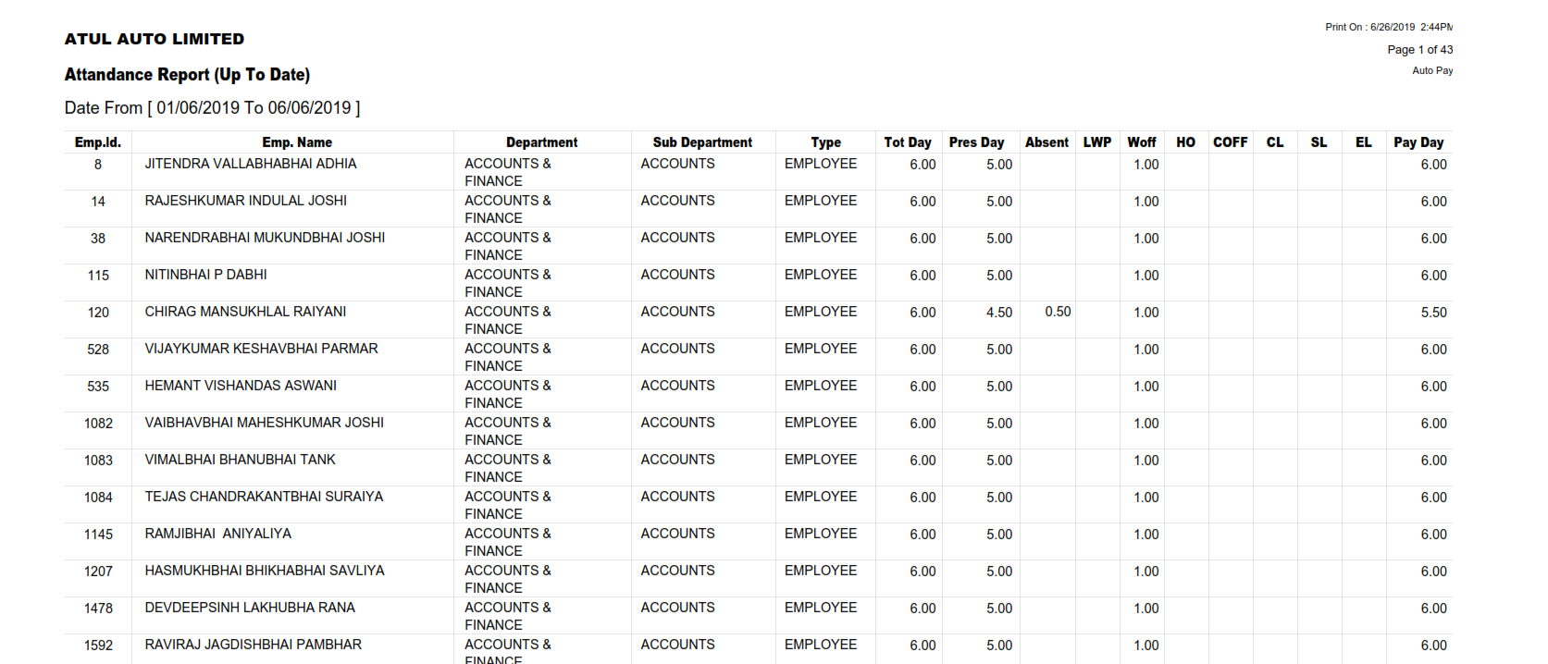
- ATTENDANCE UPTO DATE REPORT

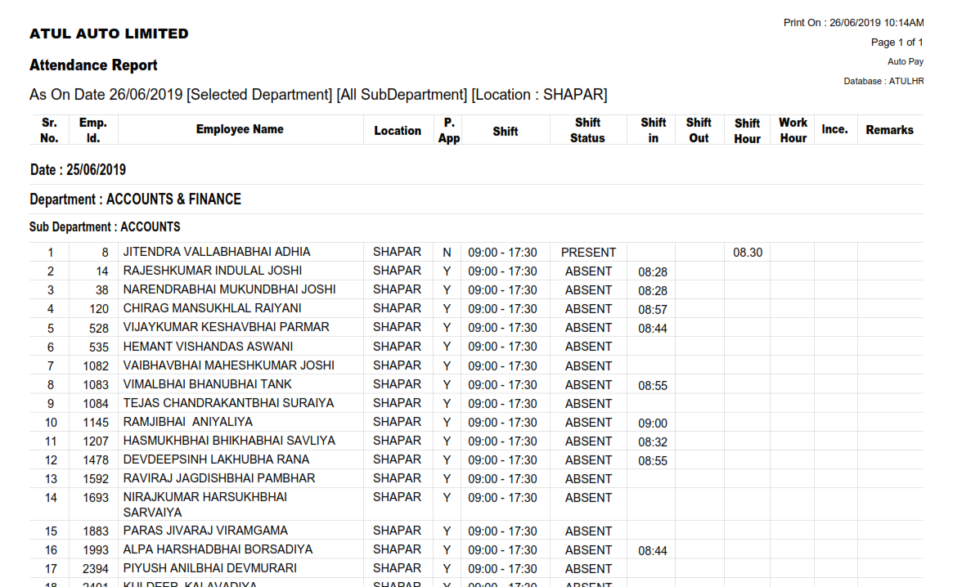
- LOCATION WISE ATTENDANCE REPORT
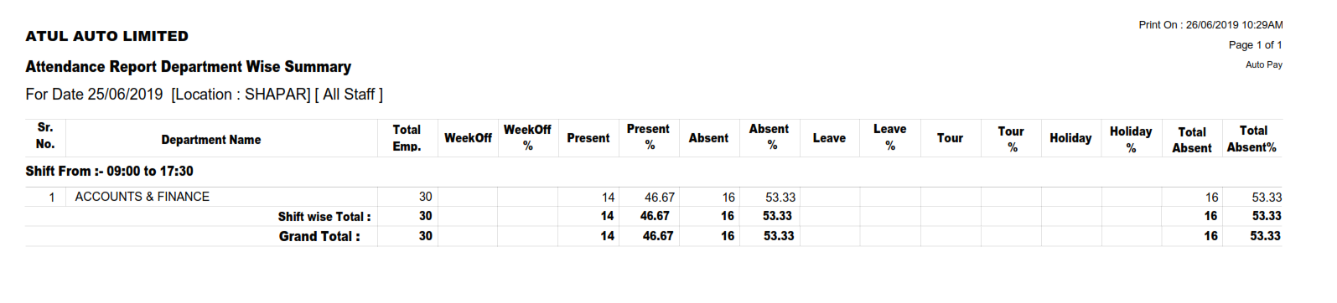
- DEPARTMENTWISE ATTENDANCE REPORT – SUMMARY

- ATTENDANCE REPORT SUMMARY – ALL DEPARTMENTS
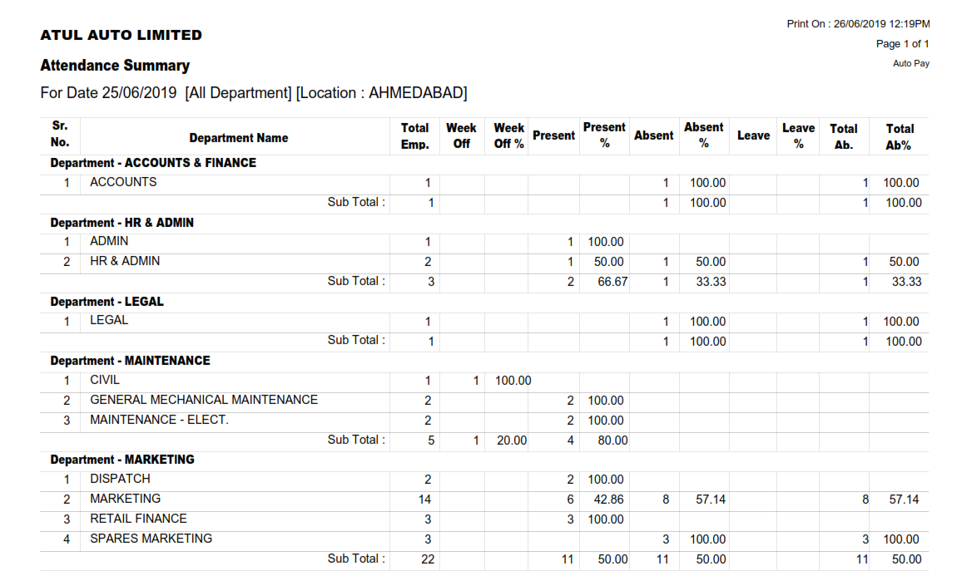

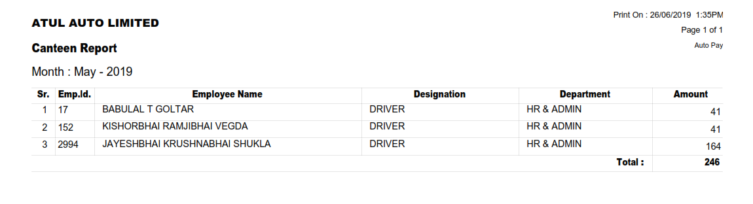
- CANTEEN REPORT

- CANTEEN AMOUNT DETAILS
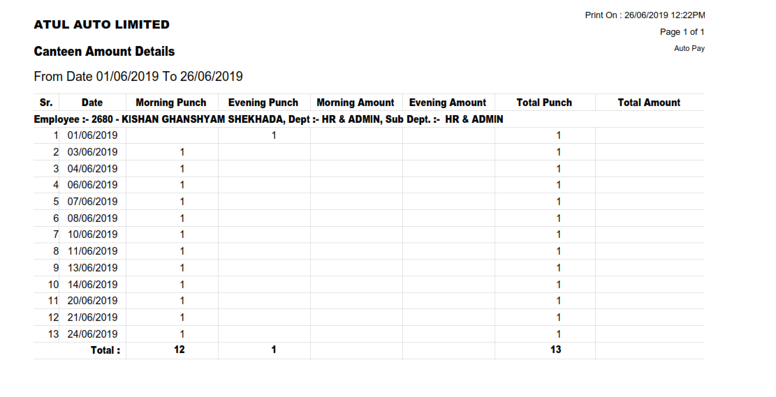

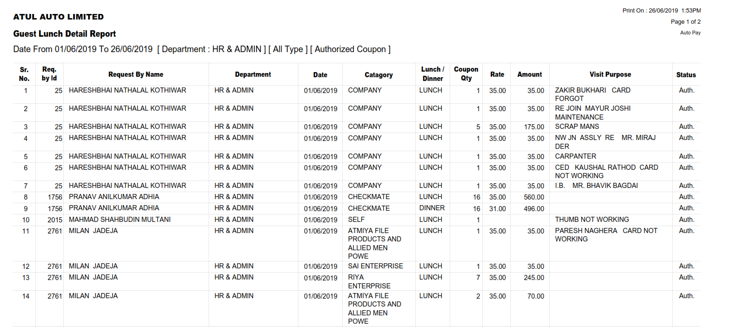
- GUEST LUNCH DETAIL REPORT

ATTENDANCE DASHBOARD
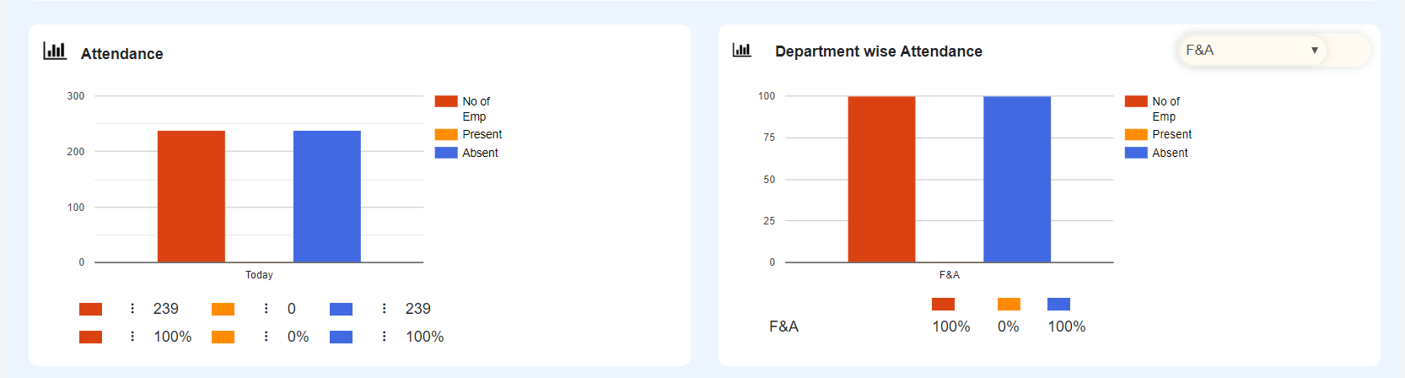

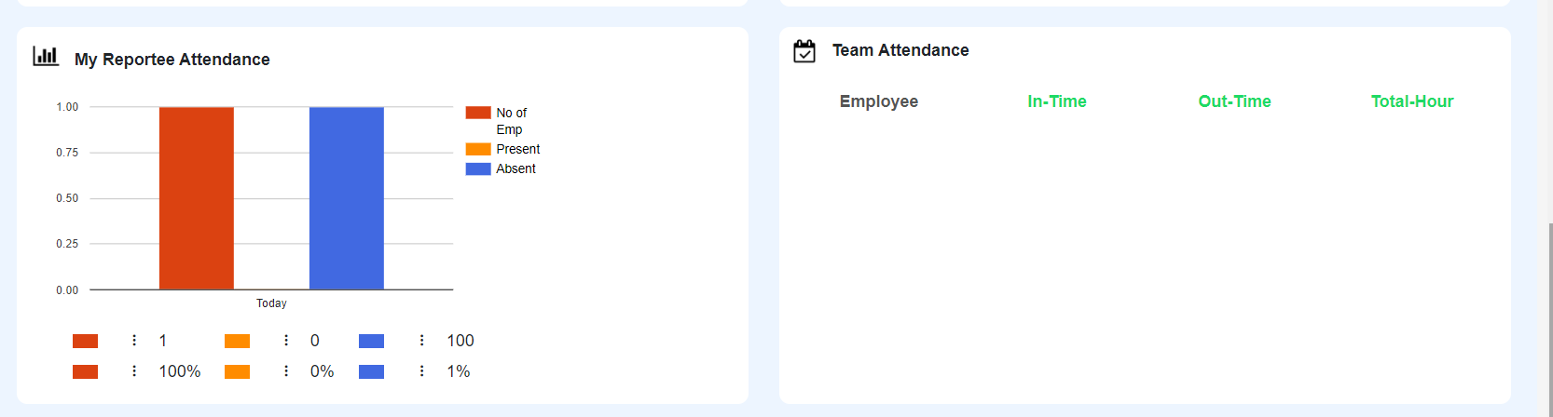

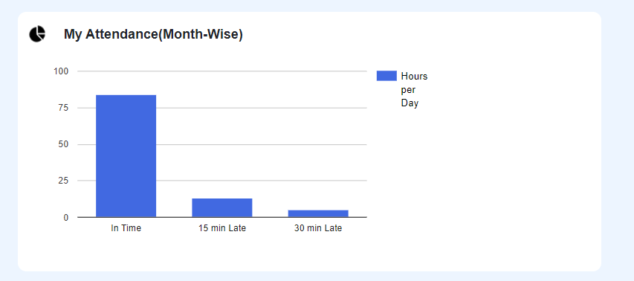

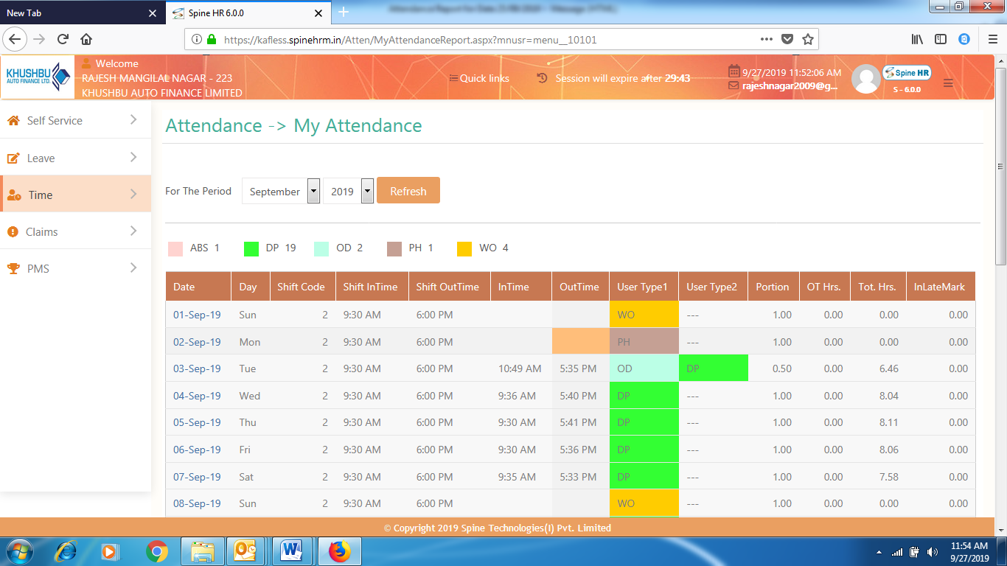

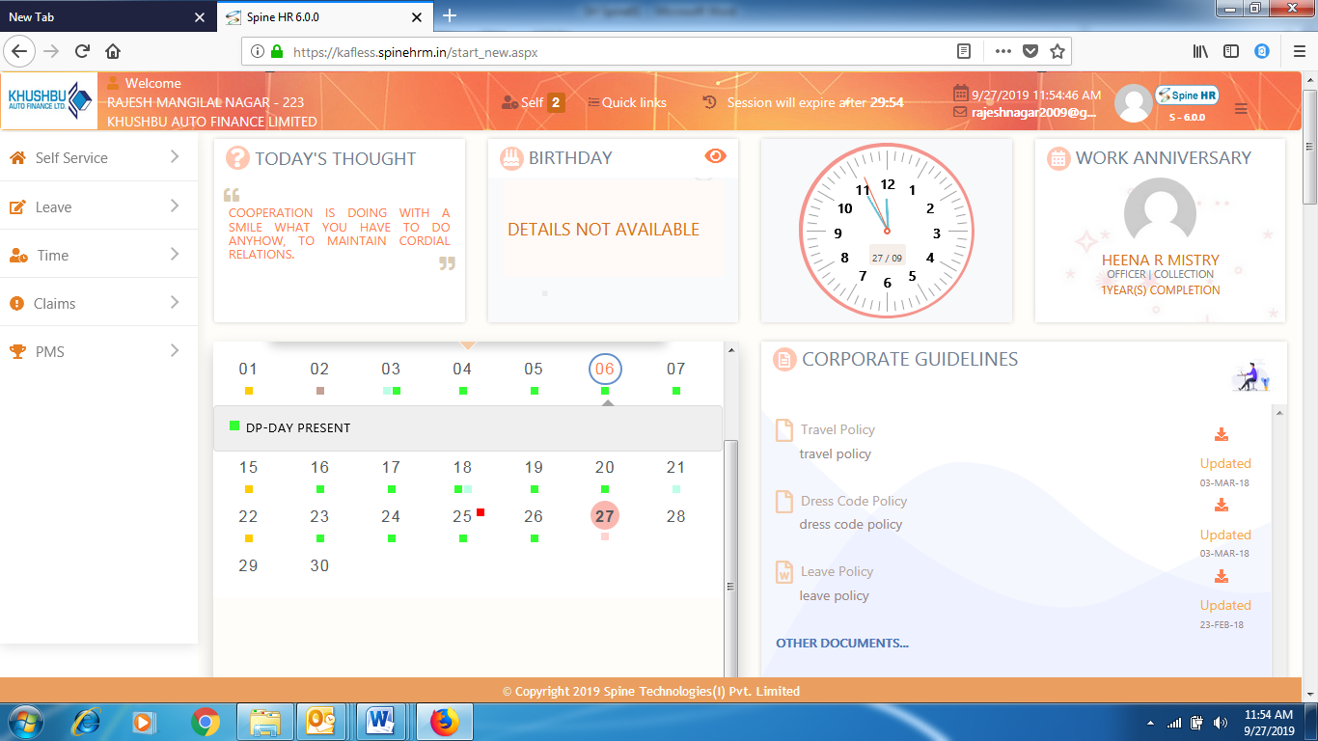

 | Name | Role | Signature | Date
Author | Mahesh Kumar Parvathareddy | CTO, SDL
Reviewer | Yatin Sanghvi | IT MANAGER, ATUL AUTO
Approver | Malay Kothari | HR HEAD, ATUL AUTO

